Creation Grand Canyon Rim & Raft Trip June 7-10, 2018
Join Eric Hovind of Creation Today &
Russ Miller of Creation, Evolution & Science Ministries
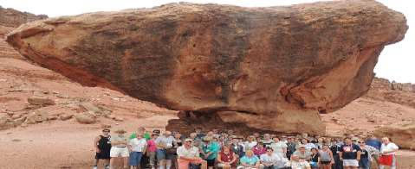
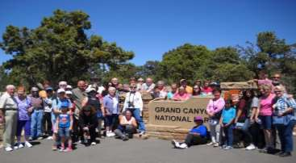
Trip Details:

The Grand Canyon is America’s most recognized landmark and one of the top tools used by secularists to support “billions of years” and Darwinism. Spend two fun-filled days rafting and exploring the chasm with Eric Russ! You will be amazed at the Truth of God’s Word seen at Grand Canyon and your faith will be emboldened!
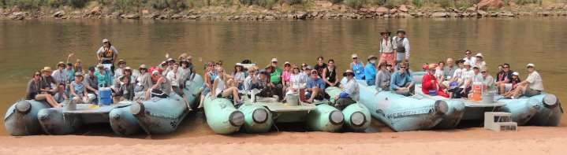
Whether young or old, this is a great Christian Rim Tour of Grand Canyon and an awesome river raft opportunity to see the Canyon from the bottom up. So bring your family and friends and experience the Grand Canyon through a Biblical worldview. We book all hotels, meals and tours so you can enjoy a great weekend!

June 7-10, 2018

June 7, 2018 Thursday Book your flights into Sky Harbor International Airport, Phoenix, AZ where you’ll catch a free shuttle to the Drury Inn and Suites, Phoenix Airport Location. *Please note: The Drury Shuttle does NOT pick up at Phoenix-Mesa Gateway airport. If you fly Allegient Airlines there you will have to arrange for your own transportation to the Drury Inn and Suites. Check in time is 3PM. Drury Inn has a “kick-back” dinner in the hotel atrium. Your hotel and dinner are included in the tour price. If you are driving you can leave you vehicle at the hotel for the duration of the trip.
June 8, 2018 Friday After breakfast a luxury bus will pick us up at the hotel and take us to Grand Canyon, and late in the day, to the historic Cameron Trading Post. Breakfast, bus, Park entrance, a picnic lunch, guided tour, dinner and hotel are included in the tour price.
June 9, 2018 Saturday After breakfast we will take a half day raft trip down the Colorado River to Historic Lee’s Ferry, where we will have a picnic lunch. This is a quiet float, suitable for travelers ages 4 and up. Our luxury bus will return us to the Drury Inn and Suites Phoenix Airport hotel location.
“Kick-back” dinner included (same as first night). Breakfast, raft trip, lunch, bus, dinner and hotel are included in your tour price.
June 10, 2018 Sunday: Breakfast at the hotel is included. Take the free shuttle to the airport. If you are flying out of Phoenix-Mesa Gateway Airport, you will need to make your own shuttle arrangements. Register on line or by downloading this form and mailing in with payment.
Please NOTE: THIS TOUR FILLS FAST. We suggest you get tickets early. If you need to cancel you can do so by April 1, 2018 for a full refund minus $20.00 processing fee. If you cancel after April 1, 2018 there will be a $200.00 charge per ticket, with the balance being refunded to you. Tickets are transferrable.
Sign Me Up for the June 7-10, 2018 Creation Grand Canyon Tour & River Raft Trip
Name

(Please list names and ages of children attending)

Address City State Zip Day time phone ______________________ Email address_______________________________
Prices: Adults: $759.00 (per adult with TWO ADULTS staying in the same room-double occupancy) Price includes three hotel nights, meals from Friday evening thru Monday morning, entrance fee to Grand Canyon, River raft trip, guides, luxury tour bus, bus driver, bottled water, snacks and gratuities. Adults are age 18 and over.

Single Occupancy: $880.00 One adult staying in room by yourself

Children: $649.00 (staying with 2 paying adults). Children are 17 years of age and under. There is easy walking and optional hiking on this trip. The raft trip is limited to those 4 years old and older.

Adults (double occupancy) # _________________x $759.00 = _____________________________________________________

Children (w/paid adults) # ____________ x $649.00= ____________________________________________________________

Single Occupancy _______ $880.00 Grand Total $ __________________________________________

PAYMENT: Go to www.creationministries.org and register at our online bookstore under Eric Hovind Grand Canyon Tour Or register by printing this form and mailing with your check (payable to CESM) to:
CESM 522 Finnie Flat Rd E623, Camp Verde, AZ 86322 Check Enclosed for:

