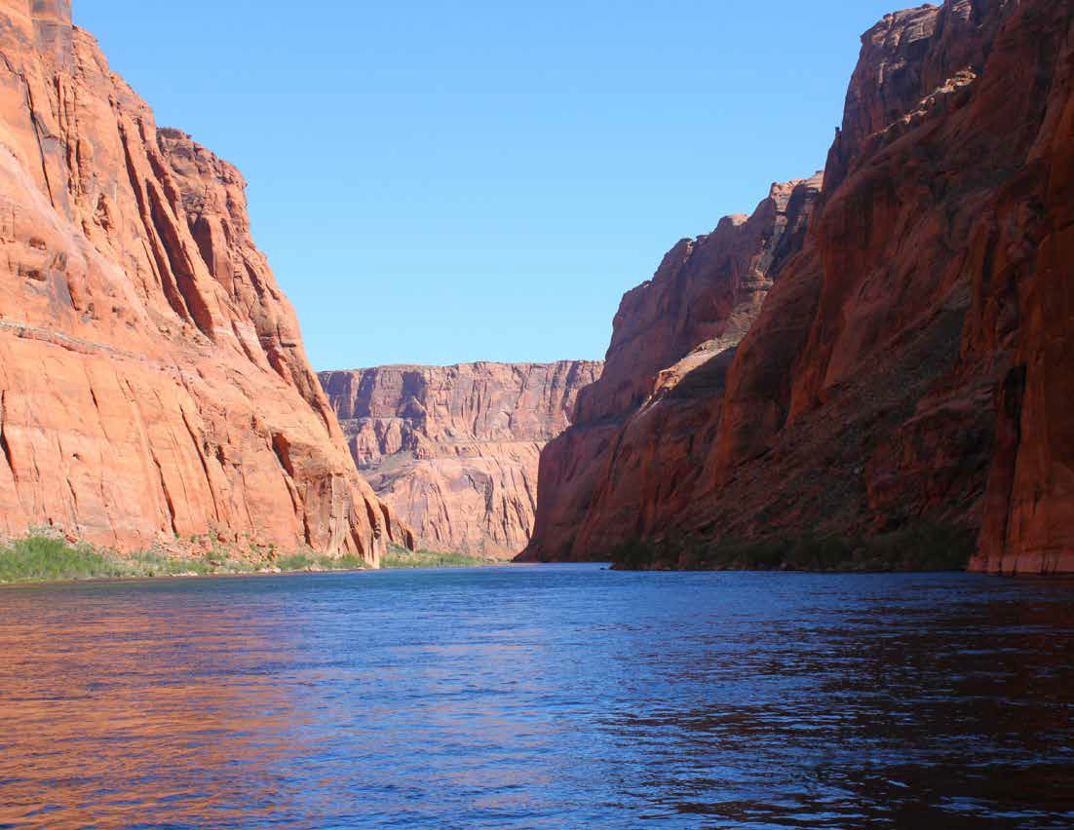
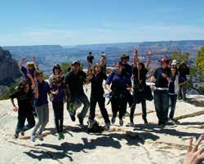
Creation Today Grand Canyon Rim & Raft Trip

Learn how Grand Canyon formed as a result of the Global Flood. See Creation Rock, Flood Layers and enjoy a family friendly Colorado River raft trip!

Learn how the Grand Canyon proves evolution is a lie!
See it for yourself!
Includes a 17-mile raft trip down the Colorado River!
Join Us!

June 7-10, 2018

Thursday-Sunday
!
Arizona
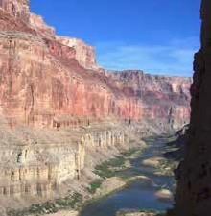
Creation Today Grand Canyon Rim & Raft Trip

Join us for an awesome tour of Grand Canyon and a Colorado River raft trip!
The Grand Canyon is America’s most recog- nized landmark. But was it carved out over millions of years or in a few days? Learning creation facts has never been this much fun!

Learn The Facts!
While the scenery alone will fill up your camera’s memory cards; we’ll spend two days looking at both the scientific & Biblical facts that will embolden your faith.
We’ll view the Canyon from atop the south rim and take a 17-mile raft trip down the Colorado River to see it from the bottom.

Youth and Adults Welcome!
Whether you’re young or old, this is a great, succinct tour of the Grand Canyon. Come as a couple, a family, an individual or group.
Register Today!
Talk to your family and friends and put this trip on your calendar! It will be a great weekend of incredible scenery, teaching and fun. Two ways to register and secure your seat. Go to www.CreationMinistries.Org online store and purchase tickets or fill out the registration form in this flier and mail in with your check.

Includes: three hotel nights, Grand Canyon tour, guided river raft trip, Luxury bus and meals from dinner on Thursday through Sunday breakfast!

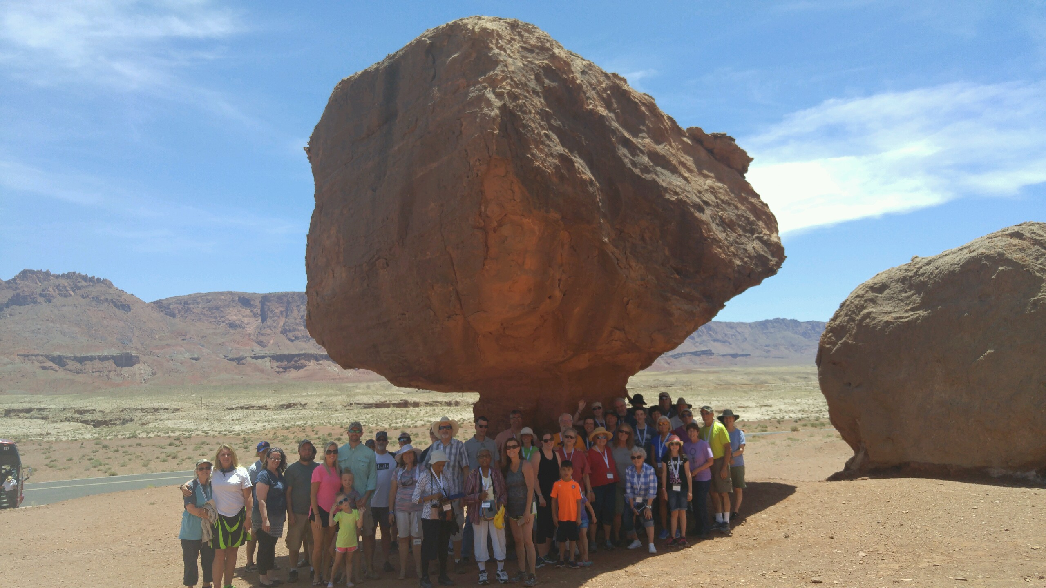

You fly into and out of Phoenix Sky Harbor Airport (PHX), AZ, for a four-day, three-night trip. You’ll learn great truths from Eric Hovind and Creation Speaker Russ Miller.

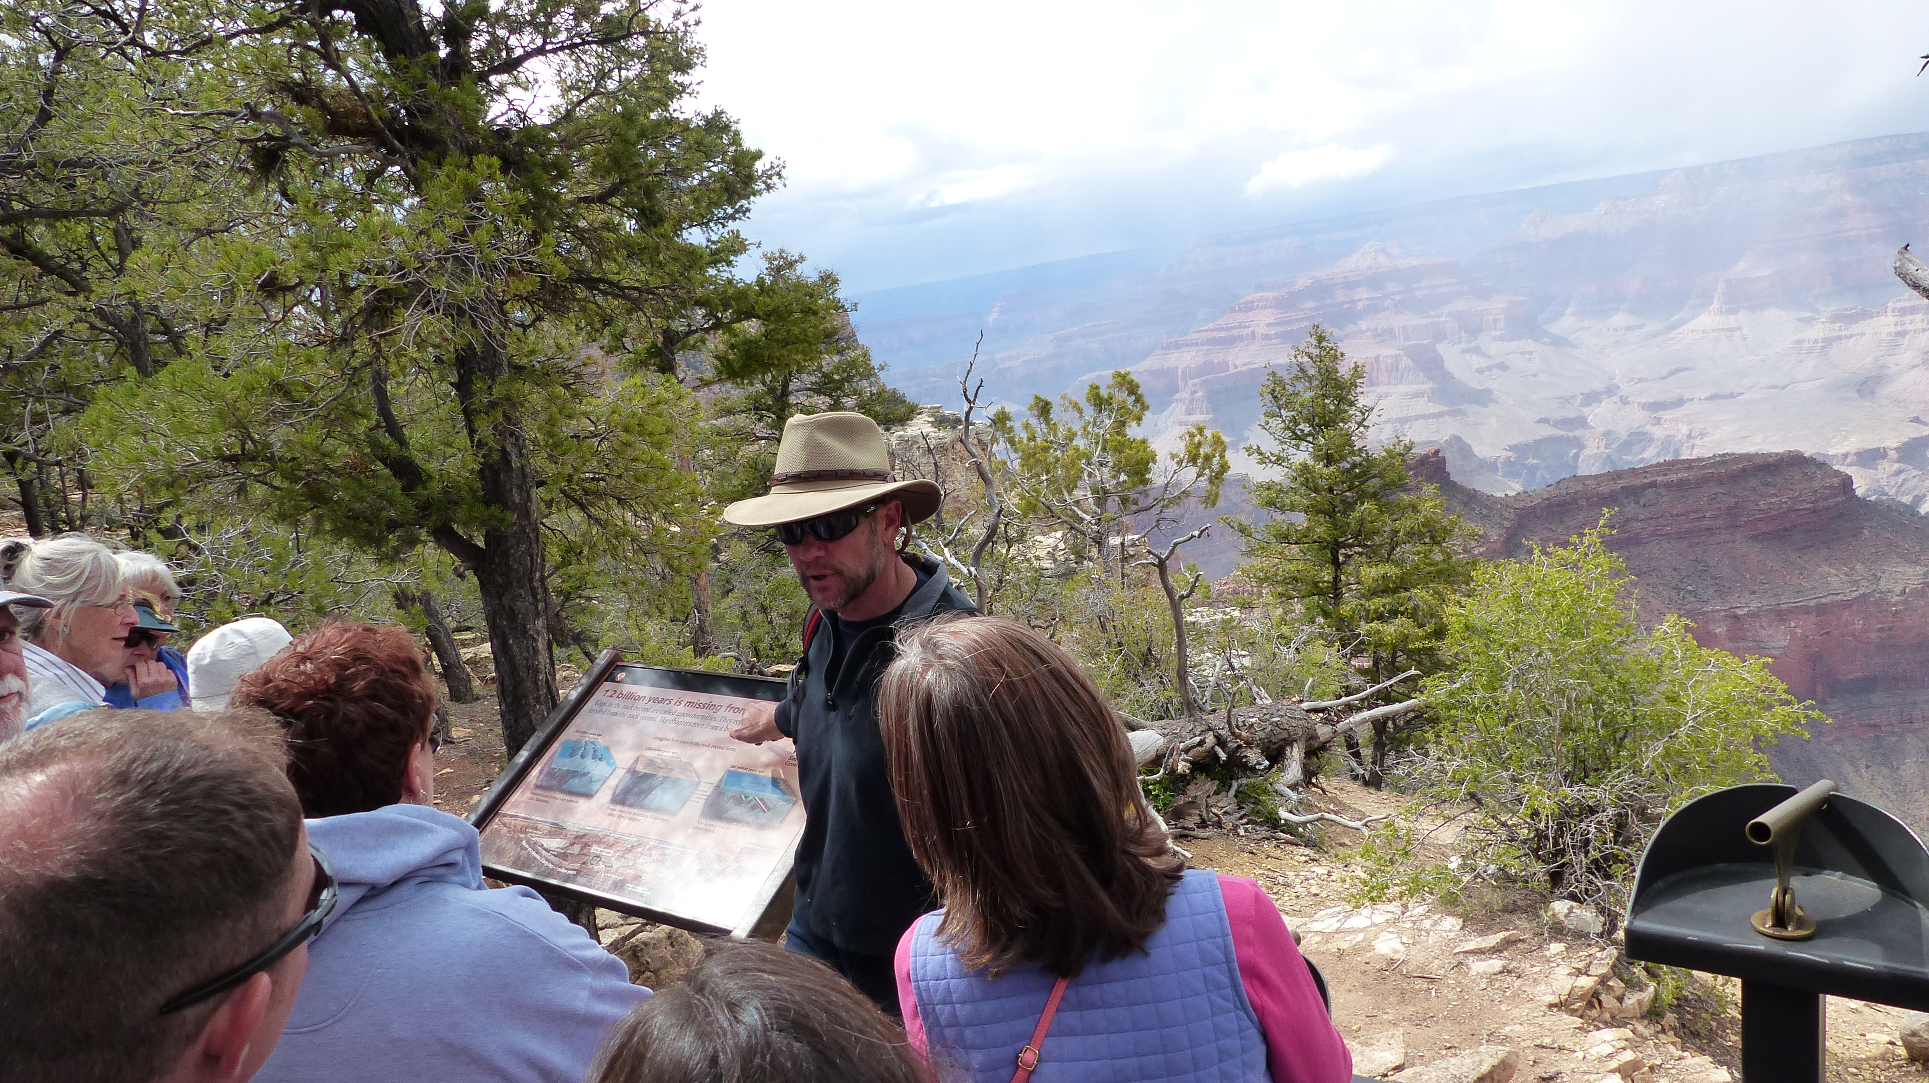
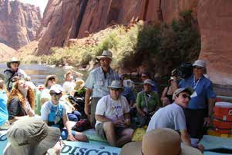
This trip will armor participants with the knowledge to defend the Bible’s world- wide flood and six-day creation account . . . critical for our youth today and exciting for Believers of all ages.

You’ll arrive on Thursday for an overnight and end your trip back in Phoenix to spend Saturday night so you can travel home on Sunday — a great four-day weekend trip.

Name Address

City
State
Zip

6/7

6/8

6/9

6/10

Drury Inn & Suites
If arriving by plane, free pick-up at Phoenix Sky Harbor Airport (PHX). Your trip begins and ends at Drury Inn.

Thursday Arrive Phoenix, AZ
- Arrive by 5:00 PM at Drury Inn & Suites, Phoenix
Friday To Grand Canyon
- Breakfast; Bus to Grand Canyon
- Lunch at Grand Canyon
• Tour Grand Canyon South & Rim-walk
• Visit Mather Point and Desert Viewpoint
- Dinner at Cameron Trading Post, overnight in Page at Sleep Inn
Saturday Raft trip
- Breakfast
- 17-mile raft trip down the Colorado River
- Lunch at historic Lee’s Ferry
- Overnight at Drury Inn & Suites, Phoenix
Sunday Travel home
- Breakfast & return to your home
Day-Time Phone
Email
Creation Today Rim and Raft 4 Days/3 Nights
Arrive in Phoenix, AZ, on Thursday, June 7th, and depart Phoenix Sunday June 10th. Registration price includes three hotel nights (Thursday and Saturday nights in Phoenix; Friday night in Page); all meals, entrance fees into Grand Canyon National Park, 17-mile Colorado River raft trip, transfers, guide, driver and class “A” touring bus.
Per person:
Adult: Double occupancy # x $759 =
Children (17 & below staying # x $649 =
with 2 adults)
Single occupancy # x $880=

Grand Total $
Please list names of all attending the trip.

- Check Enclosed (payable to CESM) ❏ Credit Card (Visa, Disc, MC, AmEx)

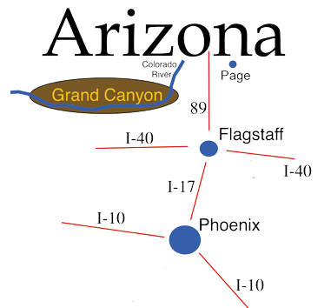
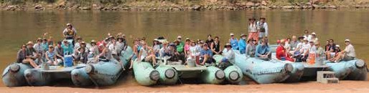
cc # - - - Security code: Exp.
Past Colorado River Raft trip

Signature
Mail to: CESM, 522 Finnie Flat Rd E623, Camp Verde, AZ 86322 or register and purchase tickets online at www.creationministries.org
For more information go to www.CreationMinistries.Org

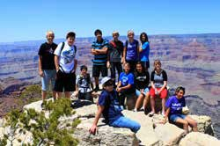
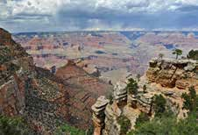

Creation Today Grand Canyon Rim & Raft Trip May 19-22, 2018

Please register early while seats are available.

Did you know layers a mile deep have been removed from ABOVE the rim of Grand Canyon?!
ver
Learn to use
Grand Canyon
to defend
Biblical Creation!

Join us !
www.CreationMinistries.Org
Led by Eric Hovind & Creationist Russ Miller

